14.85: The speed of efflux at point D is 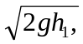 and so is 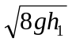 at C. The gauge pressure at C is then 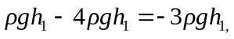 and this is the gauge pressure at E. The height of the fluid in the column is 